

February 23, 2023

DEVINE Andrew

Dublin BIkes: How pandemics change patterns

A UCD Professional Academy Project

Contents

GitHub URL: 1

Notebook Viewer: 1

Abstract 1

Introduction 1

Dataset 2

Implementation Process 3

Station Capacity Over Time-of-day September 2019 4

Setting up the model 5

Maps 6

Model Summary Statistics 8

Model Results 9

Insights & Conclusions 14

Potential Next Steps & further investigations 14

References 14

### GitHub URL:

<https://github.com/adevine95/UCDPA_AndrewDevine.git>

### Notebook Viewer:

[Jupyter Notebook Viewer (nbviewer.org)](https://nbviewer.org/github/adevine95/UCDPA_AndrewDevine/blob/7ade635b55f4d7a0f8344d8a6362fe4c685982c4/Dublin%20Bike%20Notebook%20Andrew%20Devine.ipynb)

# Abstract

This project analyses how the Covid 19 pandemic impacted usage of the bike sharing program, ‘Dublin Bikes’. It focuses on how patterns of bike usage have changed post pandemic. The entire project was performed in Python and uses both supervised and unsupervised machine learning techniques. The Python code and data can be accessed via GitHUB at the link above, the notebook viewer link shows the fully ran code and results. It takes about 12 minutes to run in total and requires the latest versions of several Python packages.

# Introduction

I chose to analyse Dublin Bikes as I’m a frequent user of the service. It has a large, freely available dataset with room for cleaning, manipulation and lots of analytic potential.

While I was able to find studies on the Dublin Bike service online, I couldn’t find anything on the impact of Covid 19. Working in life insurance has given me a lot of experience analysing impacts of the pandemic and I was keen to see if I could visualise these impacts through the Dublin Bike data. I was particularly interested in visualising how patterns of behaviour have changed since the pandemic. Rather than just usage in terms of the number of trips each day etc.

# Dataset

The data I’ve used is freely available from Dublin City Council here:

[Dublinbikes DCC - Datasets - data.gov.ie](https://data.gov.ie/dataset/dublinbikes-api)

The data includes CSV’s and an API making it a very accessible source of data

The data itself, while very large, is quite limited so left plenty of room for cleaning and manipulation.

Here’s an example of the raw data:

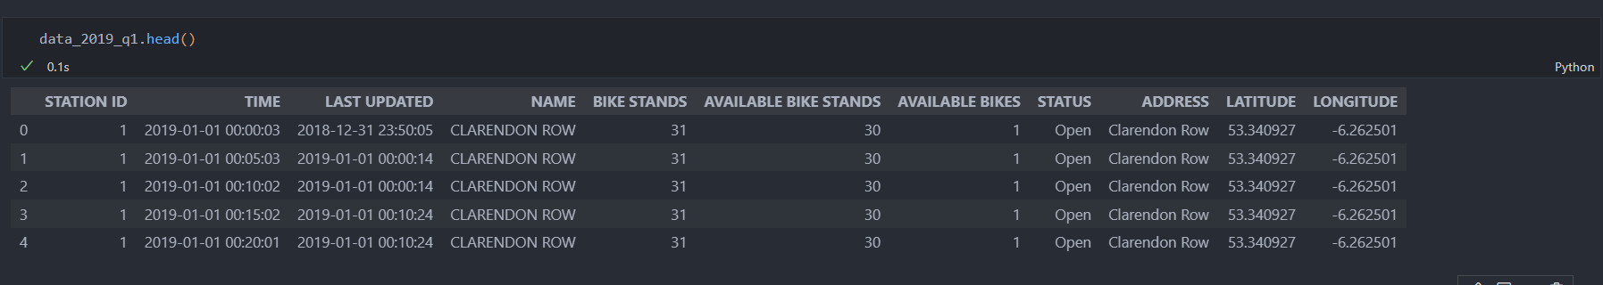

Each row shows data from a particular bike station taken at 5-minute intervals.

Showing:

* Number of stands
* Number of available bikes
* GPS Coordinates of the station
* Station Name

The data is also available through an API, with an example below:

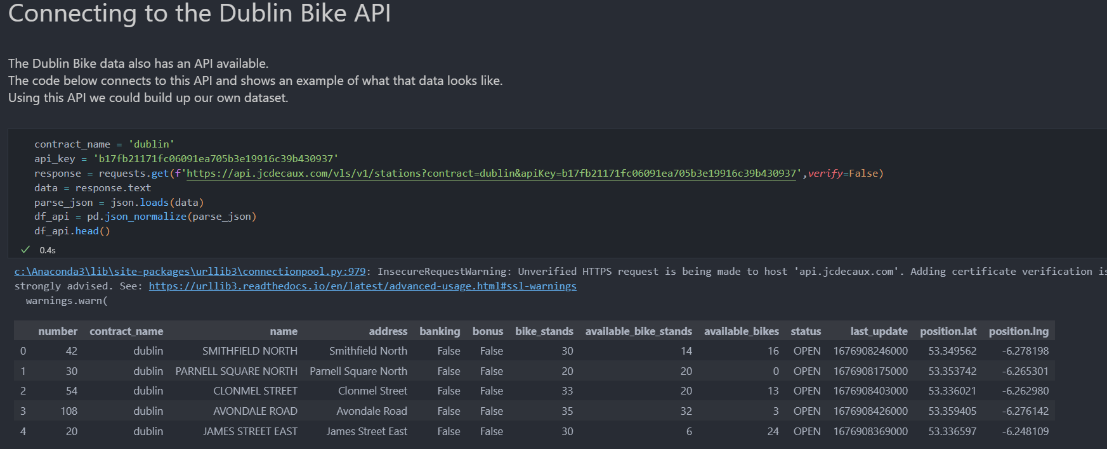

The data isn't particularly detailed, however from it, we can infer quite a lot.

I’ve used all the available data from August 2018 to December 2021, giving about 2 years of data pre and post pandemic. This amounts to 37,610,261 rows of data.

# Implementation Process

The first step was to clean the data and perform some exploratory data analysis. To clean the data, I performed the following:

* Standardised column names as lowercase
* Added columns such as:
  + A percentage of how full each station is.
  + Indicator of the date being pre or post pandemic.
  + The number of bikes taken in or out of a station in each five-minute window.
  + Day of week
  + Time of day in hours

Once cleaned, I performed some exploratory data analysis. I wanted to graph how full each bike station typically was over the course of a day. My hope was that I would see the following patterns, based on people commuting to and from work:

* **U-shaped** graphs showing stations that people leave in the morning and return to in the evening.
* **n-shaped** graphs showing stations that people arrive at in the morning and leave from in the evening.
* By showing the workday, we should see changes in the stations used for commuting. Stations located near offices should be quieter at the weekend while the opposite should be true of stations in the city centre

To visualise this, I used the Python package Seaborn. In the below graph you can see average station capacity, (number of available bikes/ number of stands) plotted over the time of day for the month of September 2019.

I’ve shown weekdays in red and the weekends in green.

### Station Capacity Over Time-of-day September 2019

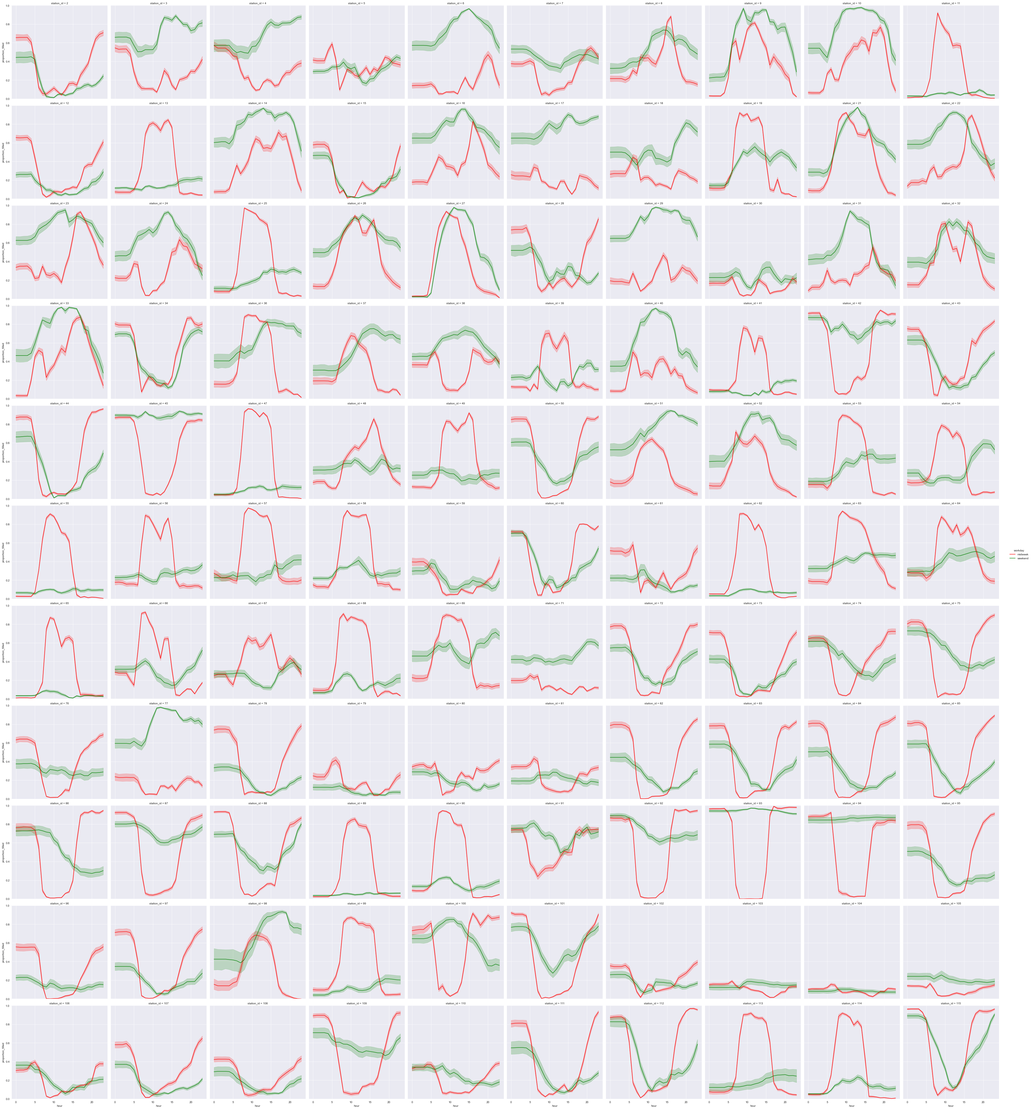

Two clear patterns emerge:

1. Some stations exhibit the U and n shaped behaviour expected. As a spot check let’s look at the stations I use frequently:
   1. When cycling to work each morning I leave station 60 (North Circular Road). Circled in blue

Which demonstrates a clear U-shaped pattern.

* 1. I arrive near my office at station 62 (Lime Street).

Circled in orange.

Which demonstrates a clear n-shaped pattern.

1. While some stations drop off in activity at the weekend, others are busier. This makes sense for 'commuter' stations near offices.
   1. Again, as an example, station 62 (Lime Street) sees much less activity at the weekend

### Setting up the model

I wanted to analyse these patterns further, to do so I decided to try and group stations together using cluster analysis. I’ve used a K-means model to try to identify which stations behave in a similar pattern.

To do this I defined functions to perform the following:

1. Clean the data further, for use in a K-means clustering model.

2. Run an Elbow test, helping identify the optimal number of clusters to use in the model.

3. Run a K-means model.

4. Plot the stations on a map of Dublin, colour coding them by cluster.

Note the code used to plot the stations is a modified version of existing code and referenced accordingly.

Below is an example of the data fed into the K-means model:

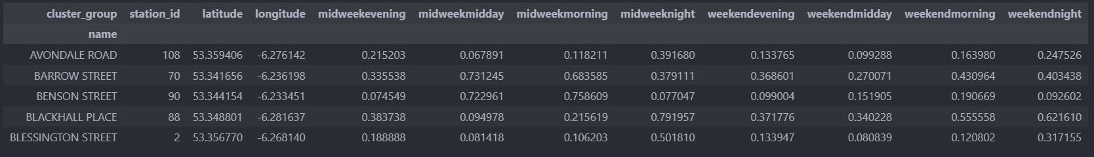

The figures here represent the average occupancy of each station throughout the day. For example, in 2019 the Barrow Street station was, on average, 73% full at midday, midweek.

The K means model successfully identified clusters of stations that behaved similarly. When I plot these clusters on a map of Dublin, we can see some interesting patterns.

The clusters for 2018 & 2019 are very similar.

### Maps

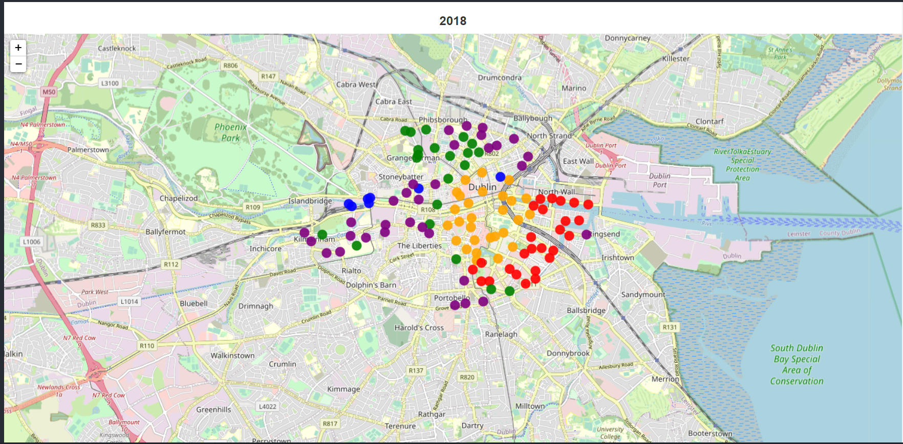

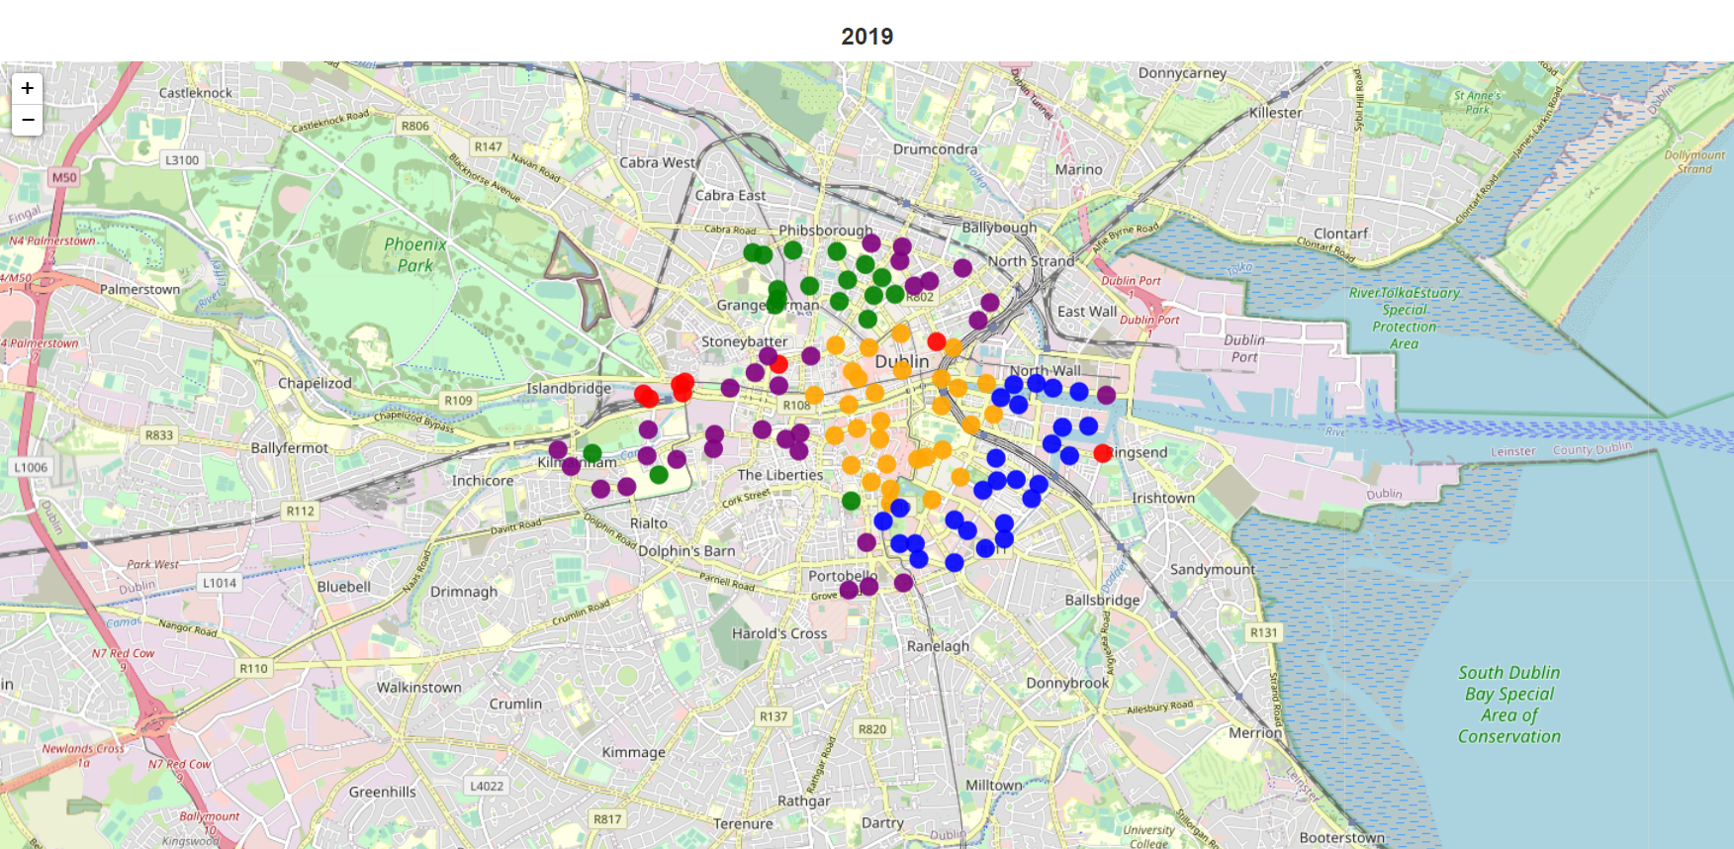

They can be split into distinct locations.

* City centre in the middle
* Offices in the Southwest
* Transport hubs in the East and West
* Residential areas in the North, South and West

We can also see that these clusters change in 2020 & 2021

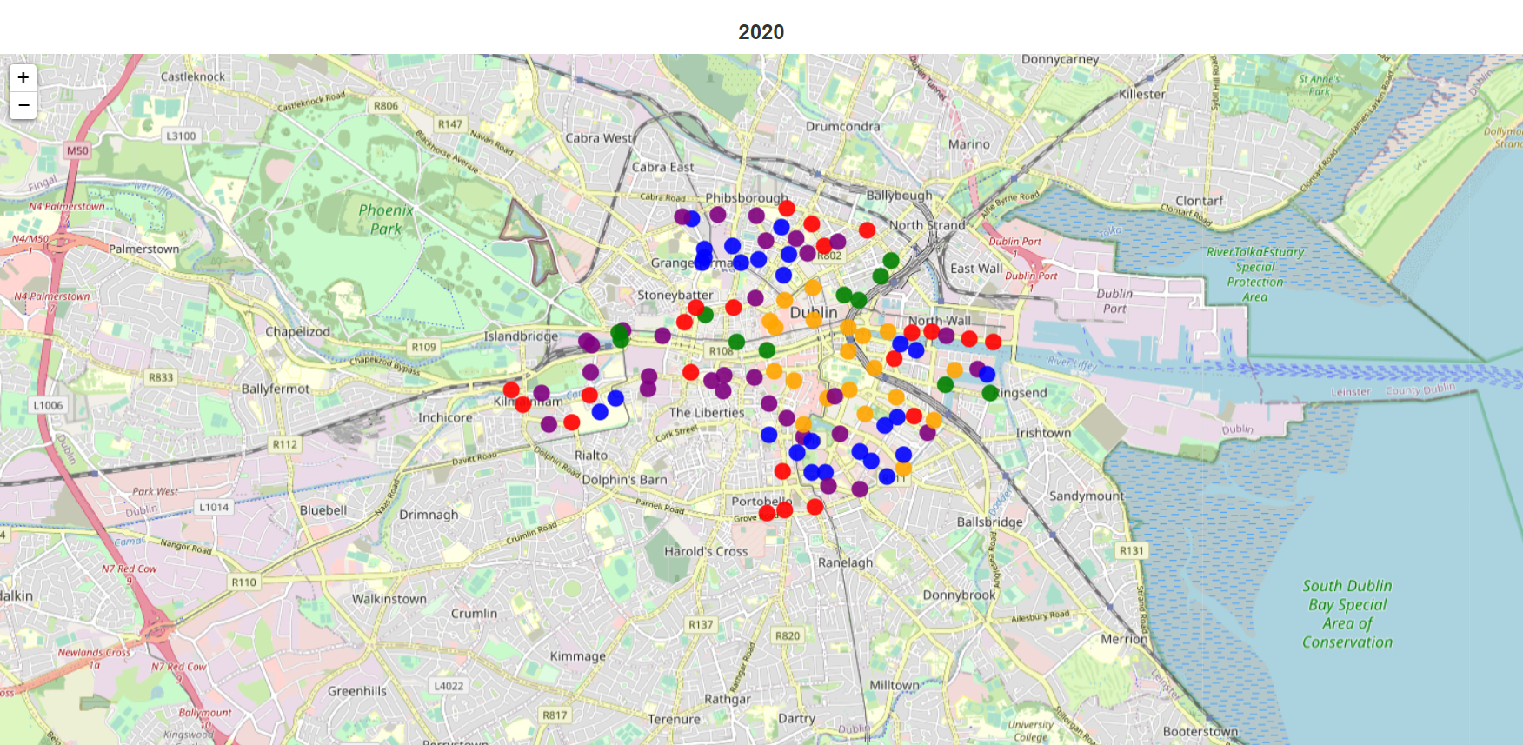

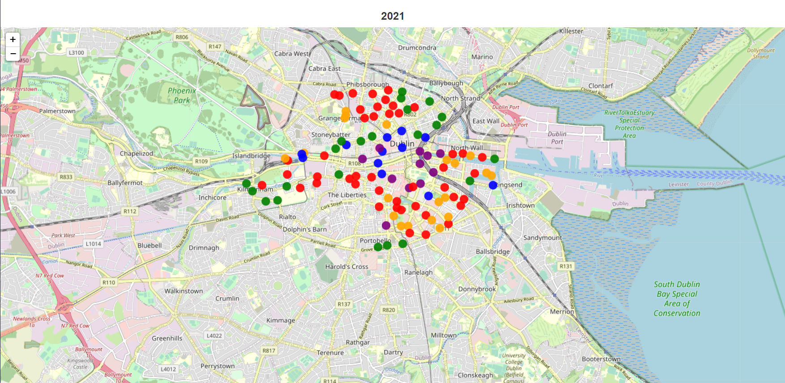

Most noticeably, the office district breaks down. This would imply the pattern of usage of these stations has changed.

So far, we've shown the bike stations can be grouped into clusters that exhibit similar patterns of usage. We've also shown these patterns have changed since the Pandemic.

Now using machine learning models, I'm going to predict the occupancy of each station. My hope is through modelling, I can visualise how impactful the Pandemic has been on usage behaviour

The total dataset is very large, around 40 million rows. For efficiency I've taken a random sample of the data to model.

I'm also going to group the occupancy into low (1), medium (2) and high (3), to make modelling it a little easier.

I’ve shown an example of the sampled data below:

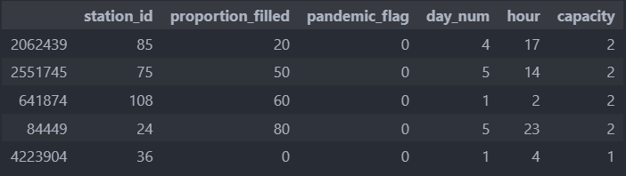

To predict capacity, I'm using a decision tree, a supervised machine learning model.

* The leaves of the tree are the variables low, medium, or high capacity.
* The branches of the tree are the combinations of station id, pandemic flag, day and time that lead to each leaf.

### Model Summary Statistics

For each model, I've output the following summary statistics:

* Precision
  + This shows the proportion of false positives produced by the model.
  + A model with no false positives has a precision score of 1.
* Recall
  + This shows the proportion of false negatives produced by the model.
  + A model with no false negatives has a recall score of 1.
* F1-score
  + This is the harmonic mean of both Precision and Recall.
  + It’s a useful summary of both values.
* Accuracy
  + This is how accurate the model is at guessing the correct answer.
  + Here it shows the % of correct predictions of station capacity.

Using the SK-Learn modules “train_test_split” function, I've split the sampled data into train and test sets. I've trained the model on 75% of the sample and will predict the capacity of the remaining 25%.

### Model Results

You can see the results of the model below:

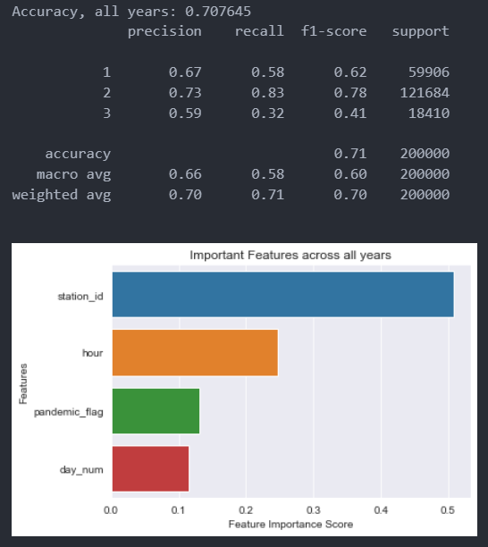

The model is about 70% accurate. I've also graphed how important each feature of the model is with Station ID being by far the most important predictor.

Interestingly, whether we're looking at a time period before or after the pandemic has more impact on the capacity of a station than the day of the week.

I've used hyperparameter tuning to improve the accuracy of the model. By running the model again, on a variety of parameters, we can select the optimal parameters for accuracy.

You can see the model has gotten slightly more accurate as a result.

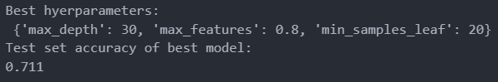

Finally, I'm going to split the data pre and post pandemic. Hopefully, there will be some indication of how bike usage has changed post pandemic in comparison.

I'm expecting the pre pandemic data to be more predictable as commuting habits were much more regular.

The results of the model ran on pre pandemic data are below:

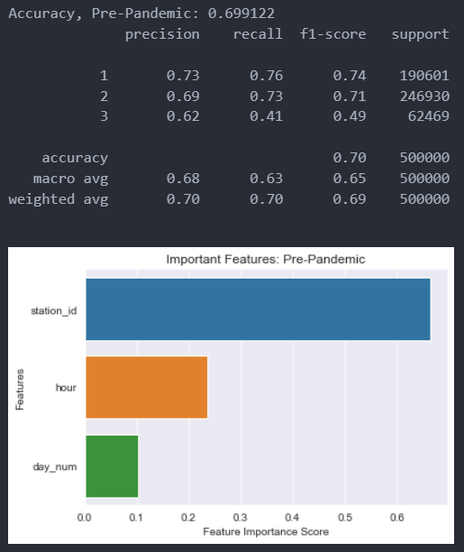

Again, the accuracy is about 70%, however we can see the model has difficulty predicting High capacities, this may be due to there being much fewer occurrences of high capacity.

#### Oversampling

To try and overcome this limitation we can over sample the high-capacity cases. After oversampling the High-capacity cases you can see the below results on pre pandemic data: 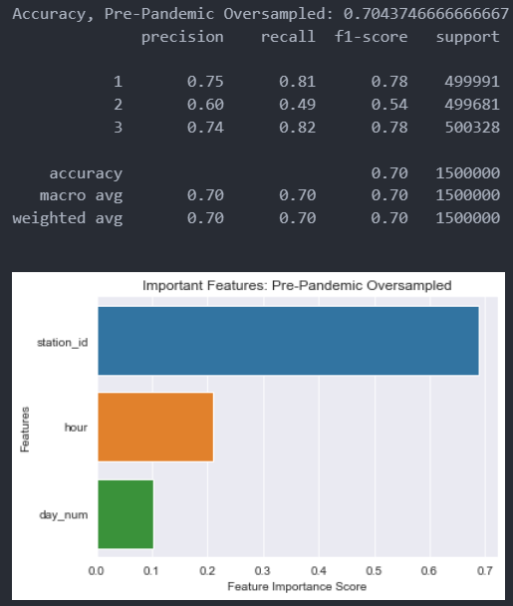

By oversampling we've improved the accuracy of predicting the chance of high and low capacity.

Let’s repeat this with post pandemic data and compare.

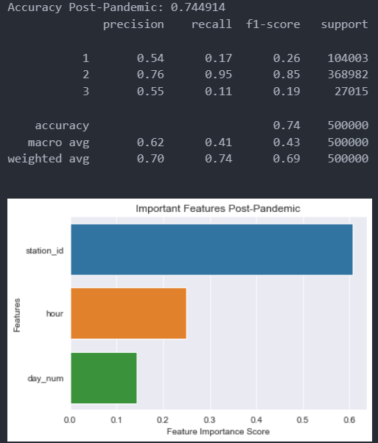

The post pandemic model shows some interesting results:

* The accuracy has gone up to 75%, however, this is misleading.
* When we look at the precision and recall of the rarer events, we can see they are both very low.

As a reminder:

* Low Precision means the model is producing a lot of false positives.
* Low Recall means the model is producing a lot of false negatives.

So, for the tail events, the post pandemic model is performing poorly. Let’s try to improve this again with oversampling.

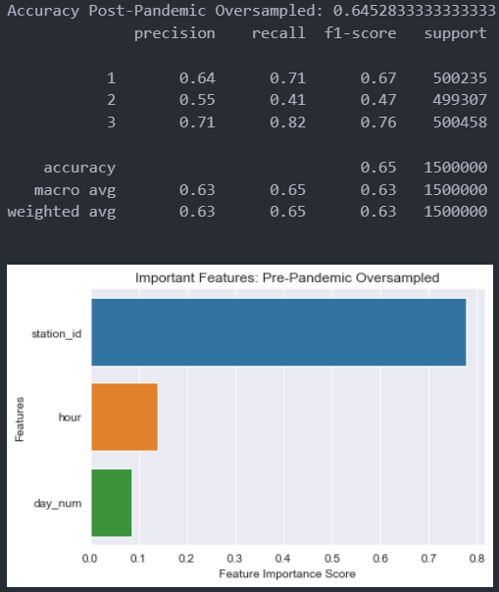

We can see a few observations:

* After oversampling, the precision and recall of the tail events have increased dramatically.
* The overall accuracy of the model however, has decreased.
* Post pandemic, the hour and day of the week has become less relevant as predictors.

This implies the following:

* Post pandemic, patterns of Dublin Bike usage have changed.
* They've become less predictable and less reliant on the time of day.

# Insights & Conclusions

* Dublin Bike usage in 2018 and 2019 was fairly predictable.
  + Bike stations exhibited clear patterns in behaviour, driven by the weekly 9 -5 commute.
* The stations themselves can be grouped into clusters.
  + Stations in certain areas of the city exhibit similar patterns of usage.
  + The three clearest areas of influence are:
    - Retail (City Centre)
    - Residential (North, West and South Dublin)
    - Commercial (East / South East Dublin)
* The Covid 19 Pandemic altered Dublin Bike usage.
  + People are commuting at less predictable times.
* As a result, Dublin Bike usage in 2020 and 2021 was less predictable.
  + Commuting patterns have changed.
  + The weekly 9-5 commute has become more flexible.
* This has led to a change in the pattern of behaviour post pandemic.
  + Station capacity is less correlated with the time of day and day of the week

### Potential Next Steps & further investigations

If I were to continue this analysis I’d focus on the following:

* Improved modelling through:
  + Increased data
  + Parameter tuning
  + Use of Random forests
  + Further pre processing data by splitting stations by use ie:
    - Retail
    - Residential
    - Commercial
* Further analyse the changes in bike usage post pandemic:
  + Overall usage levels
  + Changes in time of travel ie people arriving/ leaving the office at lunch.

# References

Devine, A. (2023) *Adevine95/UCDPA_ANDREWDEVINE*, *GitHub*. Andrew Devine. Available at: https://github.com/adevine95/UCDPA_AndrewDevine.git (Accessed: February 20, 2023).

Dublinbikes DCC (2018) Data.Gov.IE. Dublin City Council. Available at: https://data.gov.ie/dataset/dublinbikes-api (Accessed: February 20, 2023).

Breslin, R. (no date) *Rachelbreslin/dublin_bikes: Clustering and forecasting-driven analysis of Dublin bikes public data to examine movement patterns and behaviours*, *GitHub*. Available at: https://github.com/rachelbreslin/dublin_bikes (Accessed: February 24, 2023).